IFB299

Application Design and Development

Personal Portfolio

Tutor: Ben Saljooghi

Student: Chun-Ting Chen

Student Number: N8720347

**Page following section:**

1. **Title page …………………………………p.1**
2. **Release1 & 2………………………………p.3 – p.4**
3. **Sprint Plan 1&2…………………………..p.5 – p.6**
4. **Website design……………………………p.6 - p.8**
5. **HTML & CSS code………………………p.9 - p.14**
6. **Test case…………………………………..p.15**

**Release1 & 2**

First, Louis and I decide to working on code of the website. We discussed on the release plan for our website design and I provided some information about our searching page and making the filter that customer can be select their house detail.

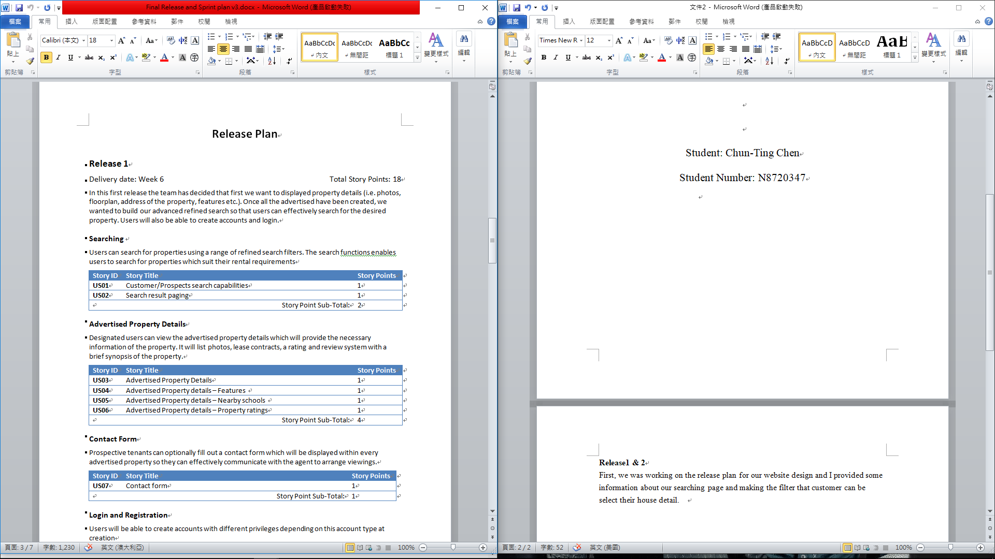

For the Property detail page, we will put in the detail of feature, nearby school and rating system. So we provide more information and advertised our property.

For



For the Login and Registration page, we design it with the filter so the customer, agent can easily to login in to the system. And the customer can register their account on the same page.

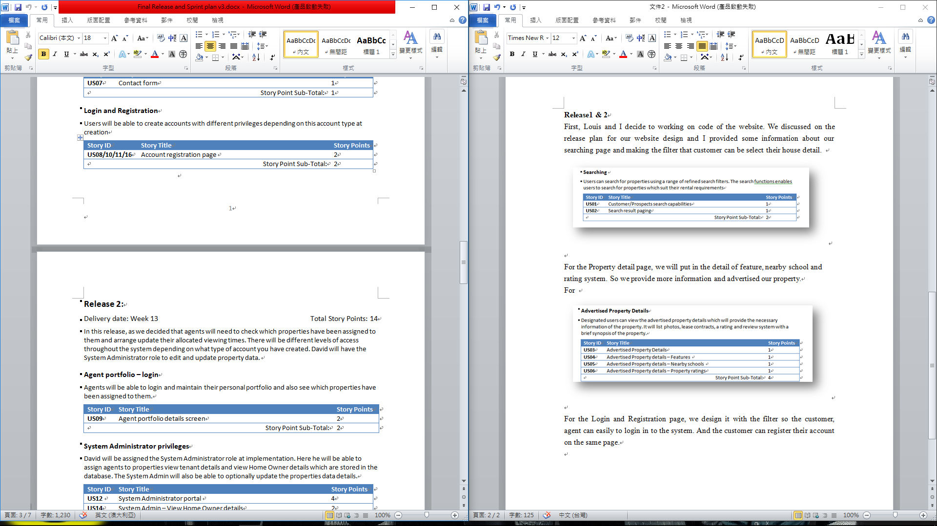



We also design the system administrator privileges that David can assign the System Administrator role at implementation. Here he will be able to assign agents to properties view tenant details and view Home Owner details which are stored in the database.

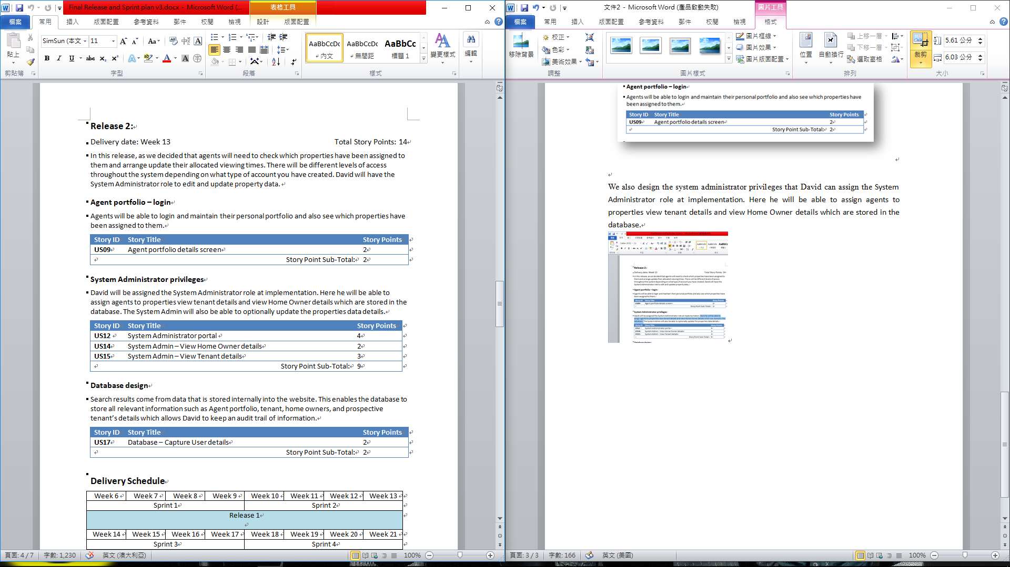Finally, we are going to create the database to store all the information from the website such as Agent portfolio, tenant, home owners, and prospective tenant’s details.

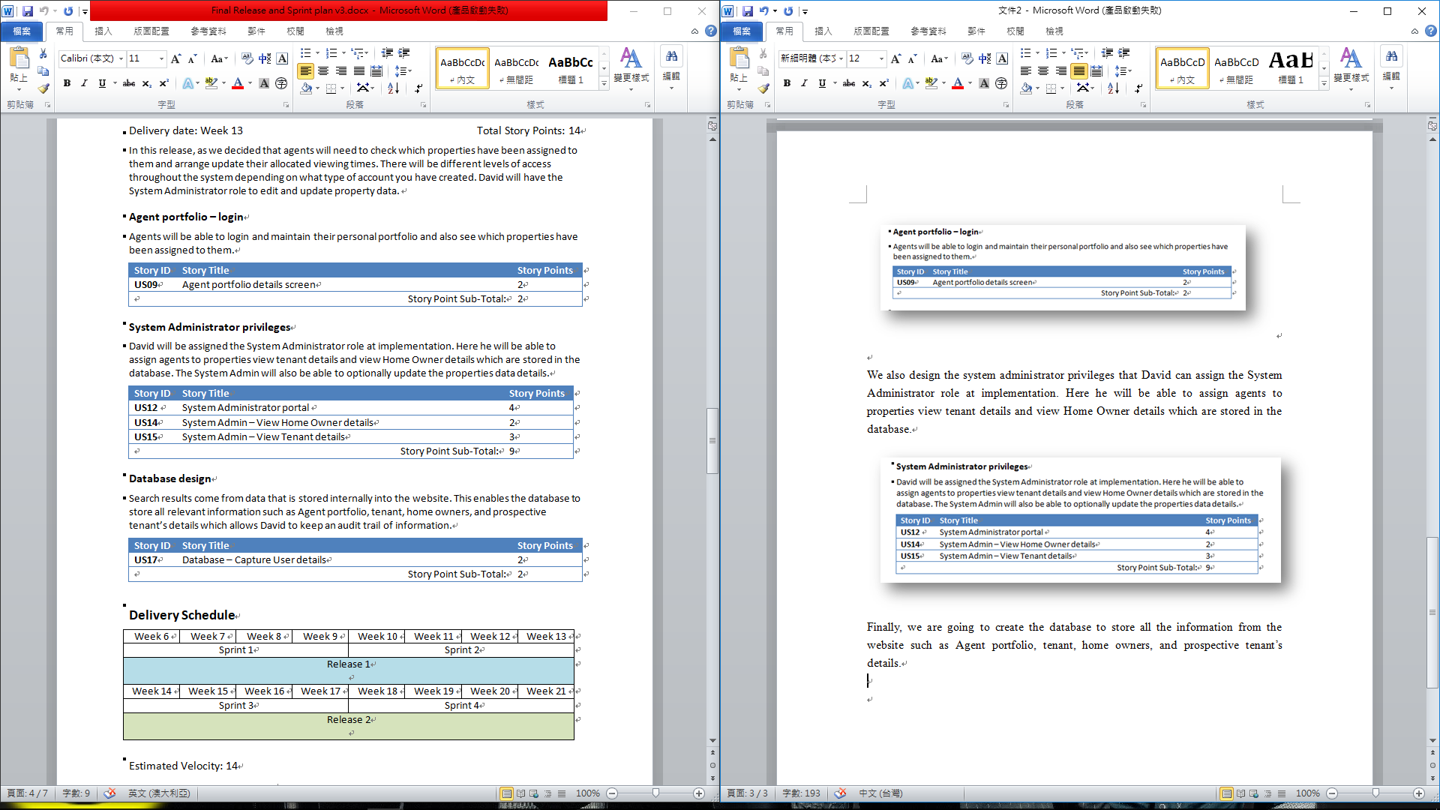

**Sprint Plan 1&2**

We have done our Property search page but the information didn’t link to the database as some reason. So we decided to cross out the task and working on sprint 2.

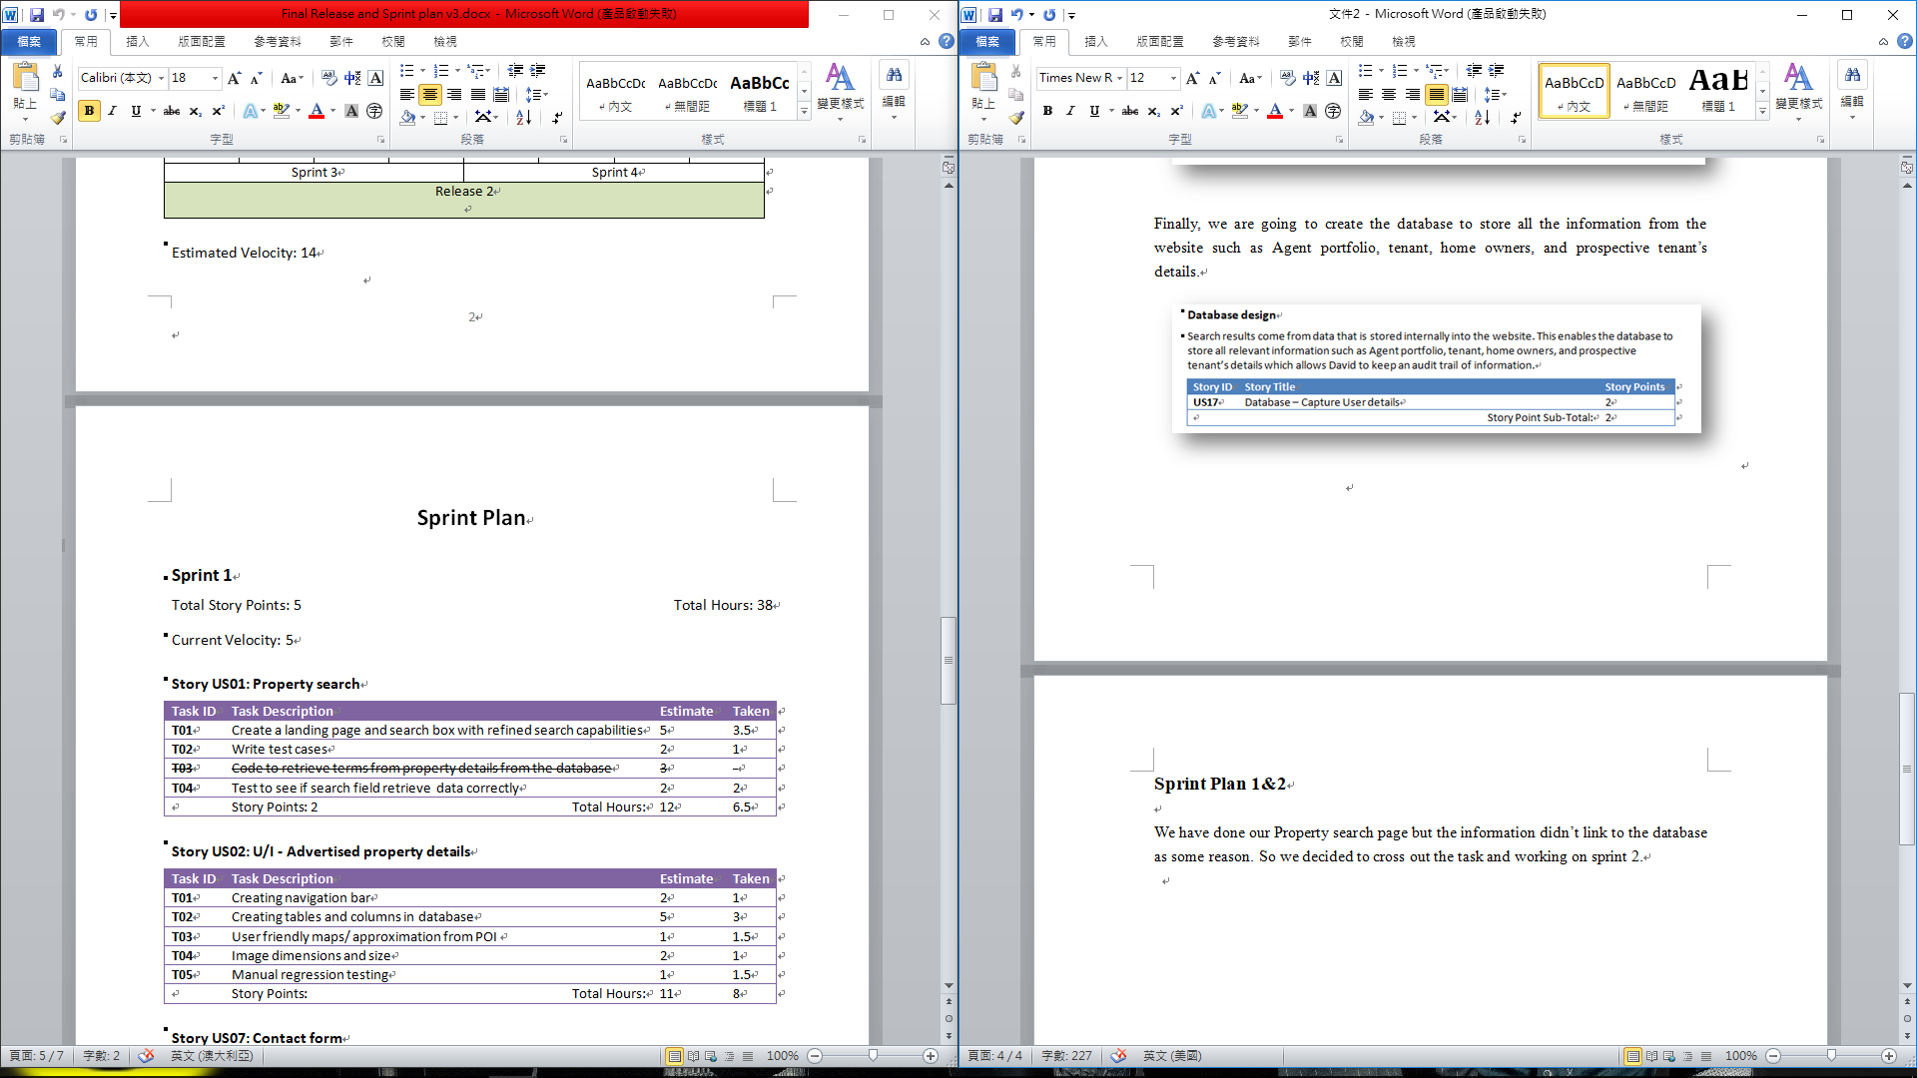

For the login and registration page we still have the same trouble with the database so we cross out the task we haven’t done and put it in to sprint 2 and continue to working on it.

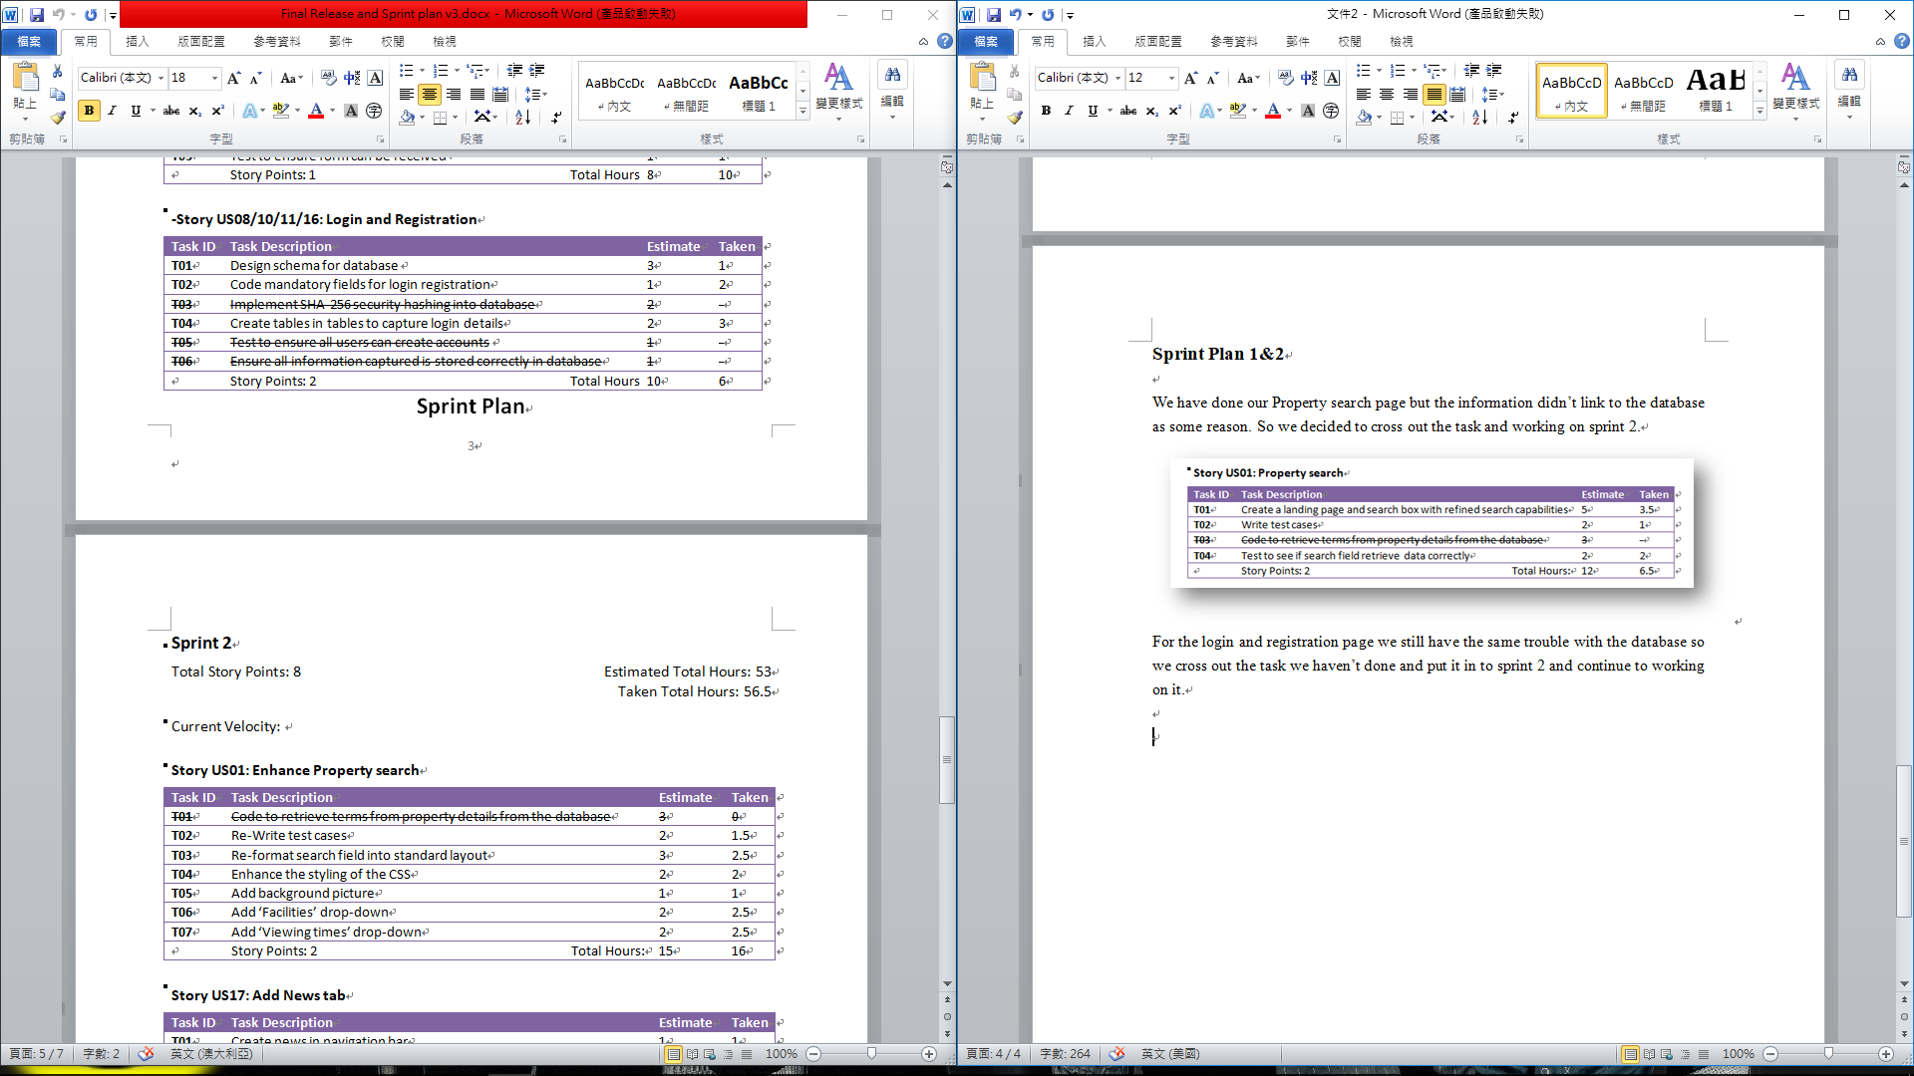

Move on to the sprint 2, I start working more on the property search page and adding the background, Facilities and viewing time drop-down filter. So the customer can get more detail for the properties. But the database still didn’t work it out.

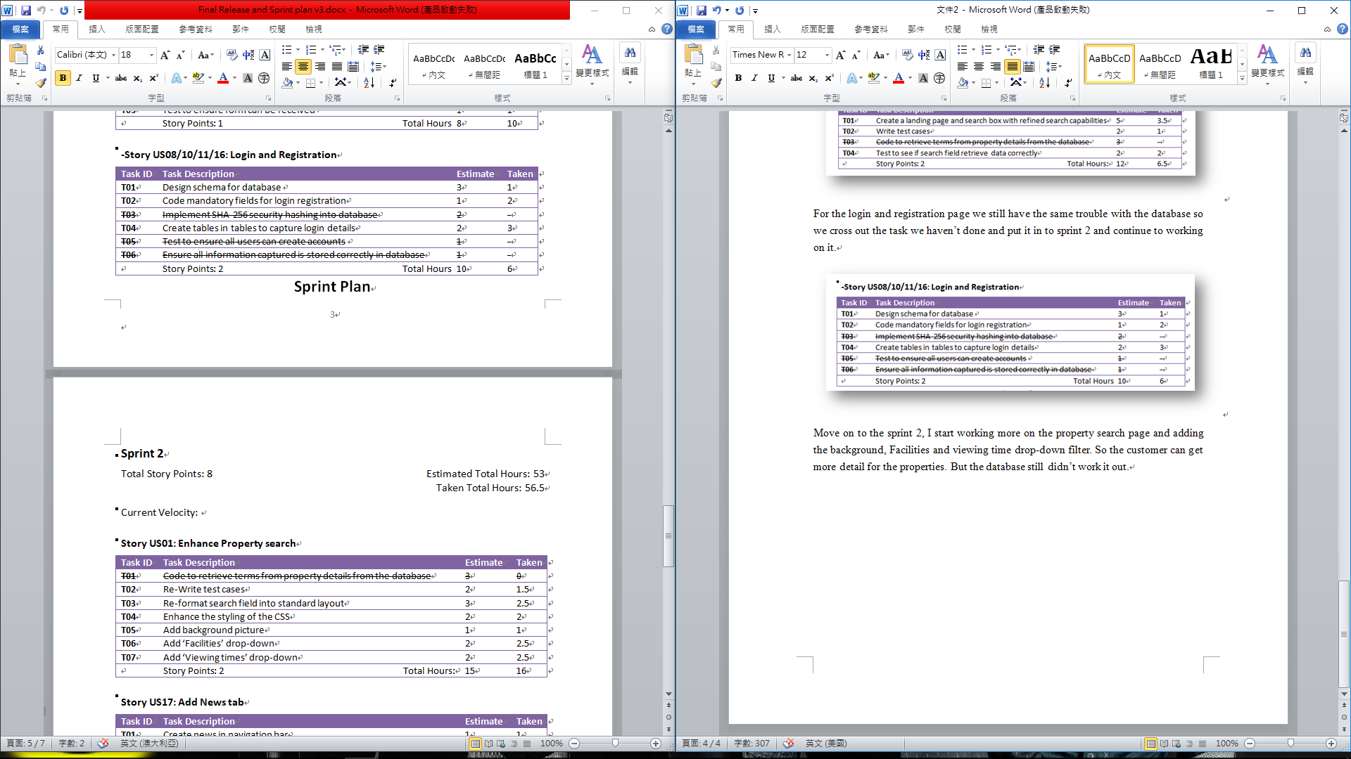

I also created the News page for customer to see the latest property information, so people can get the newest information the page.

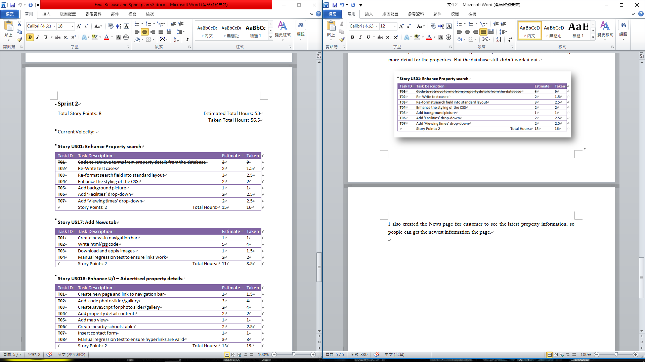

**Website design**

This is our login page that people can register or login by the page.

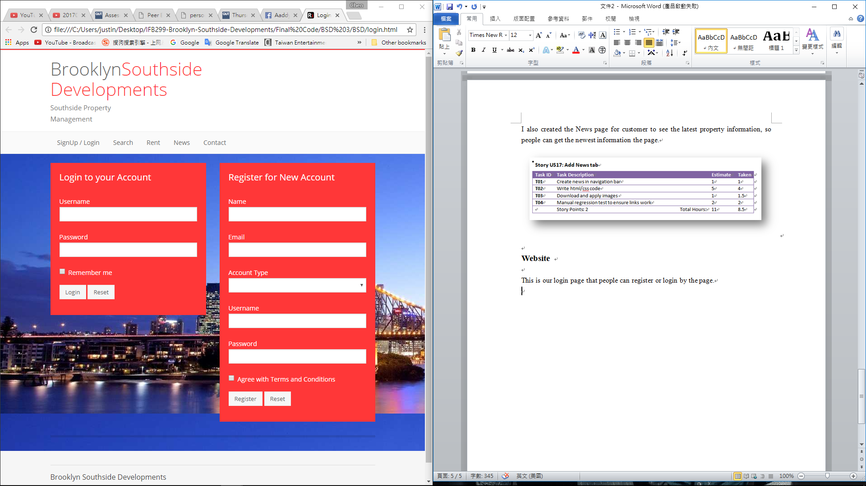

For the search page, I made the filter that customer can get more detail from the properties.

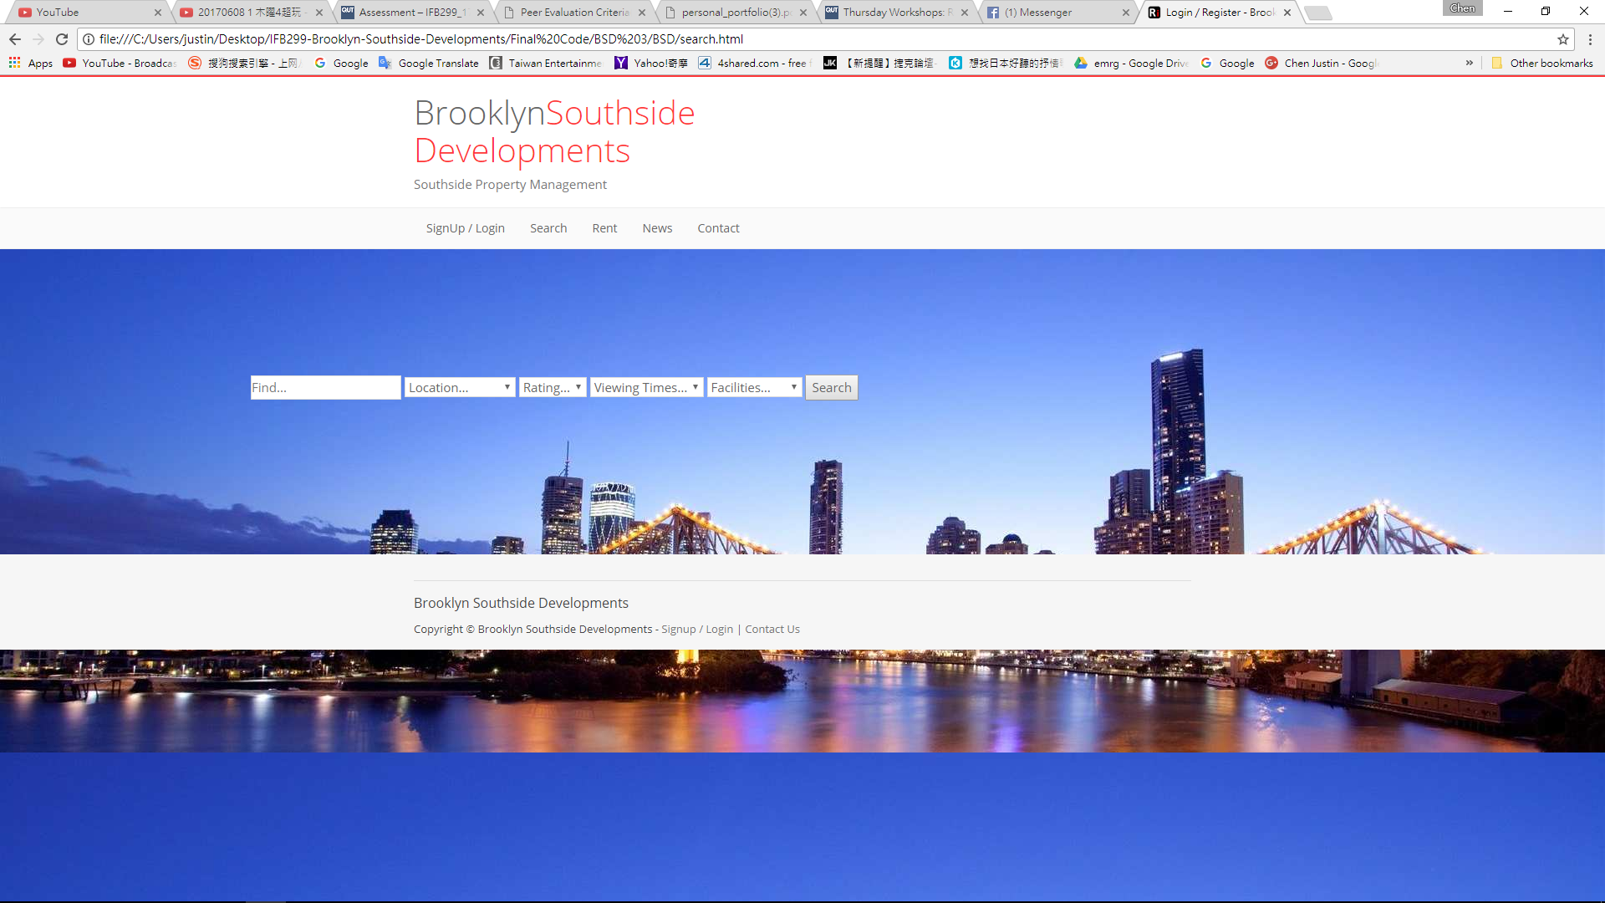

I also create a News page to show the latest property news to the customer.

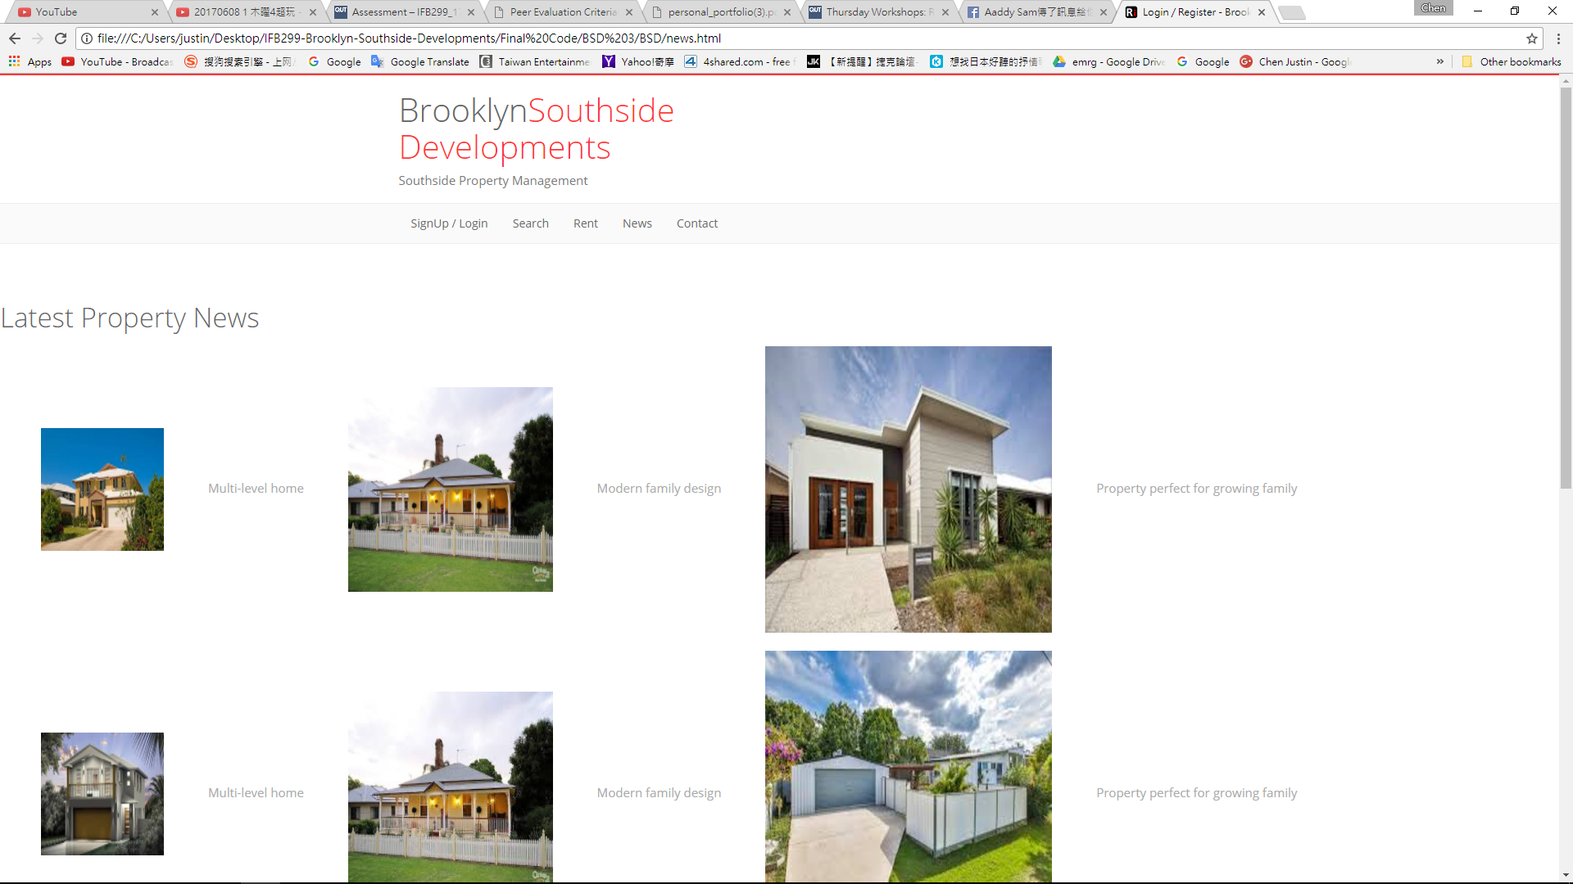

The property page also has the search bar that customer can easily to select the opinions from the filter and see what they need.

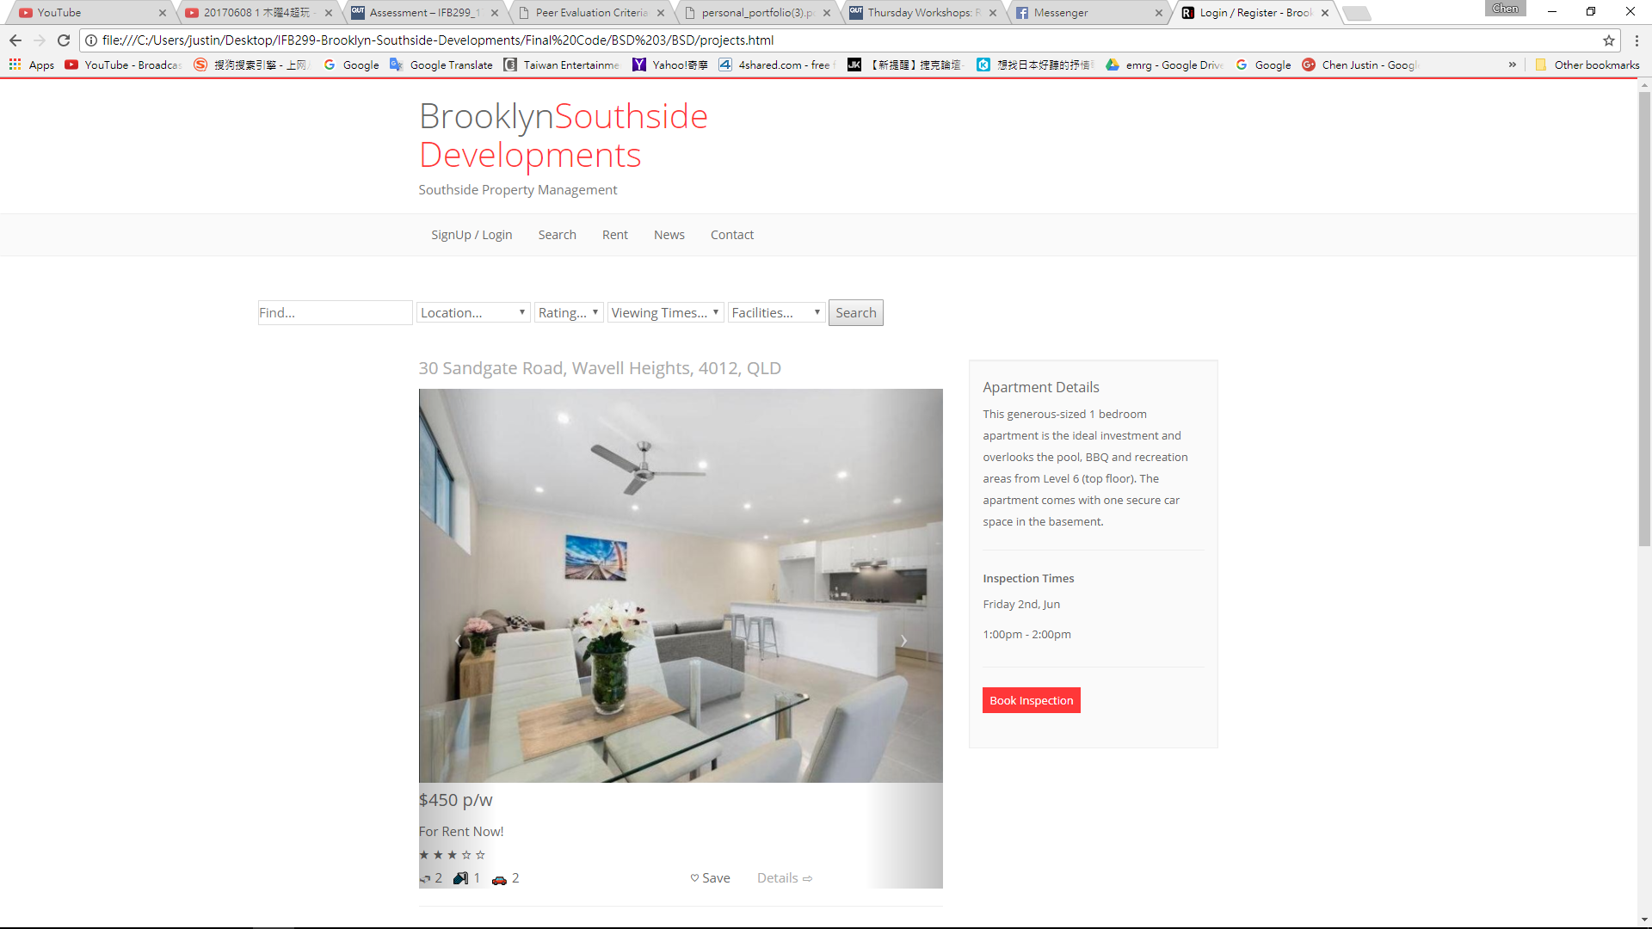

I was also working on the Navigation bar and background for the entire linking page.

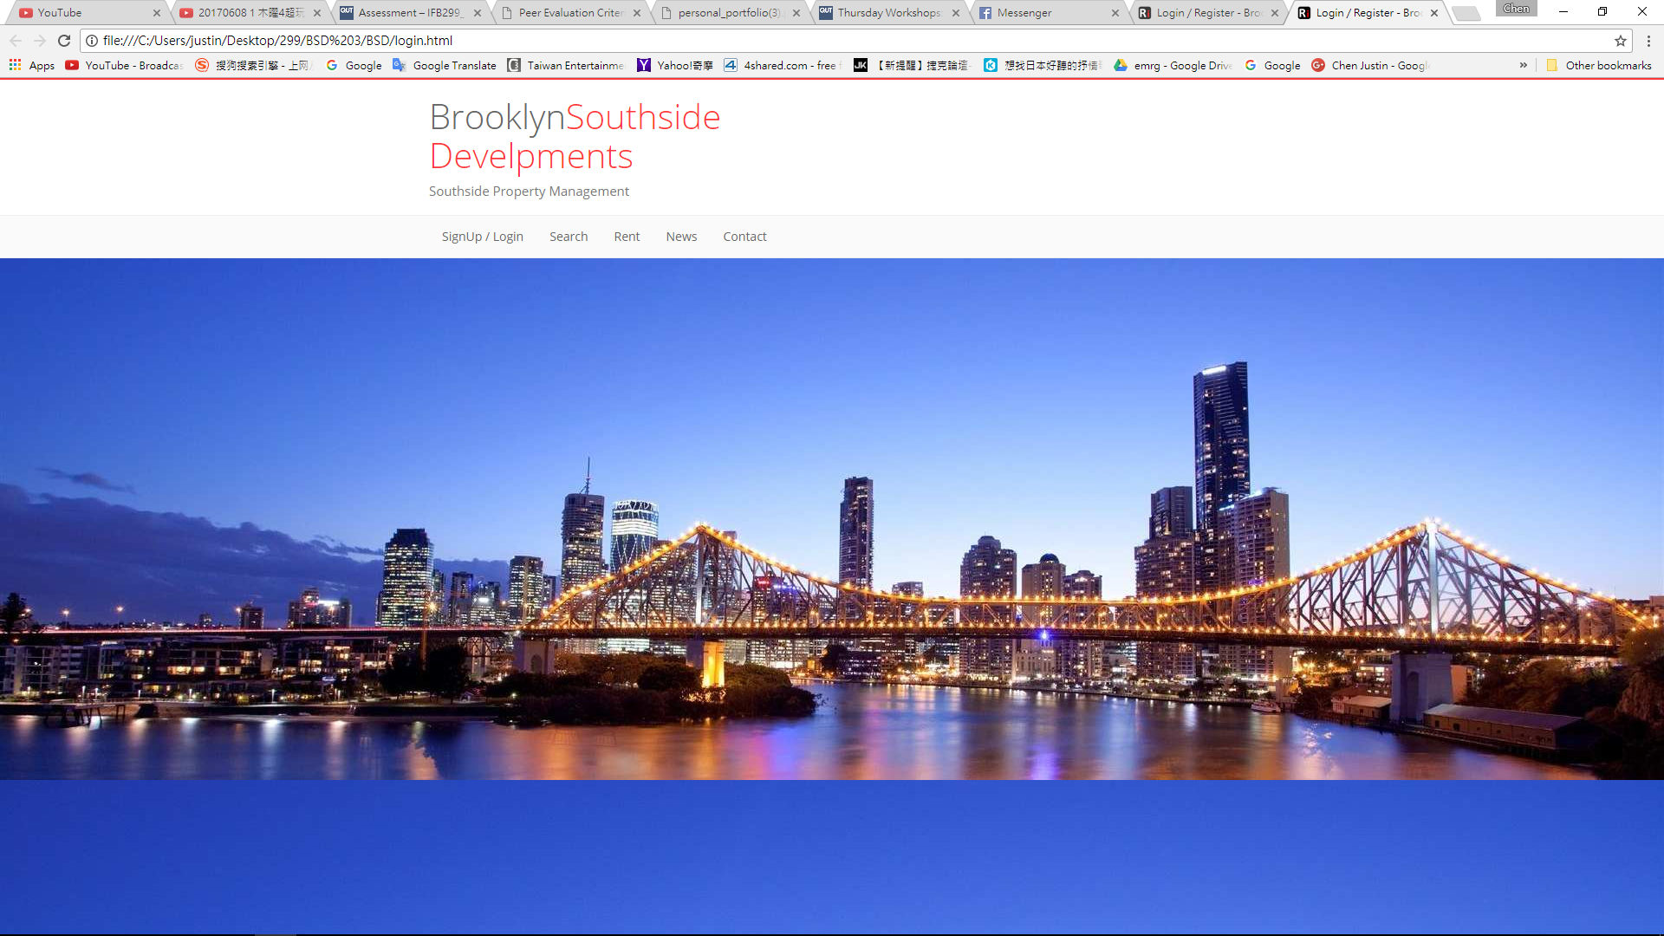

**HTML & CSS code**

This is the Login Page html code with the Navigation bar and it also provide the Login code and registration code design by Loius. (From login.html file)

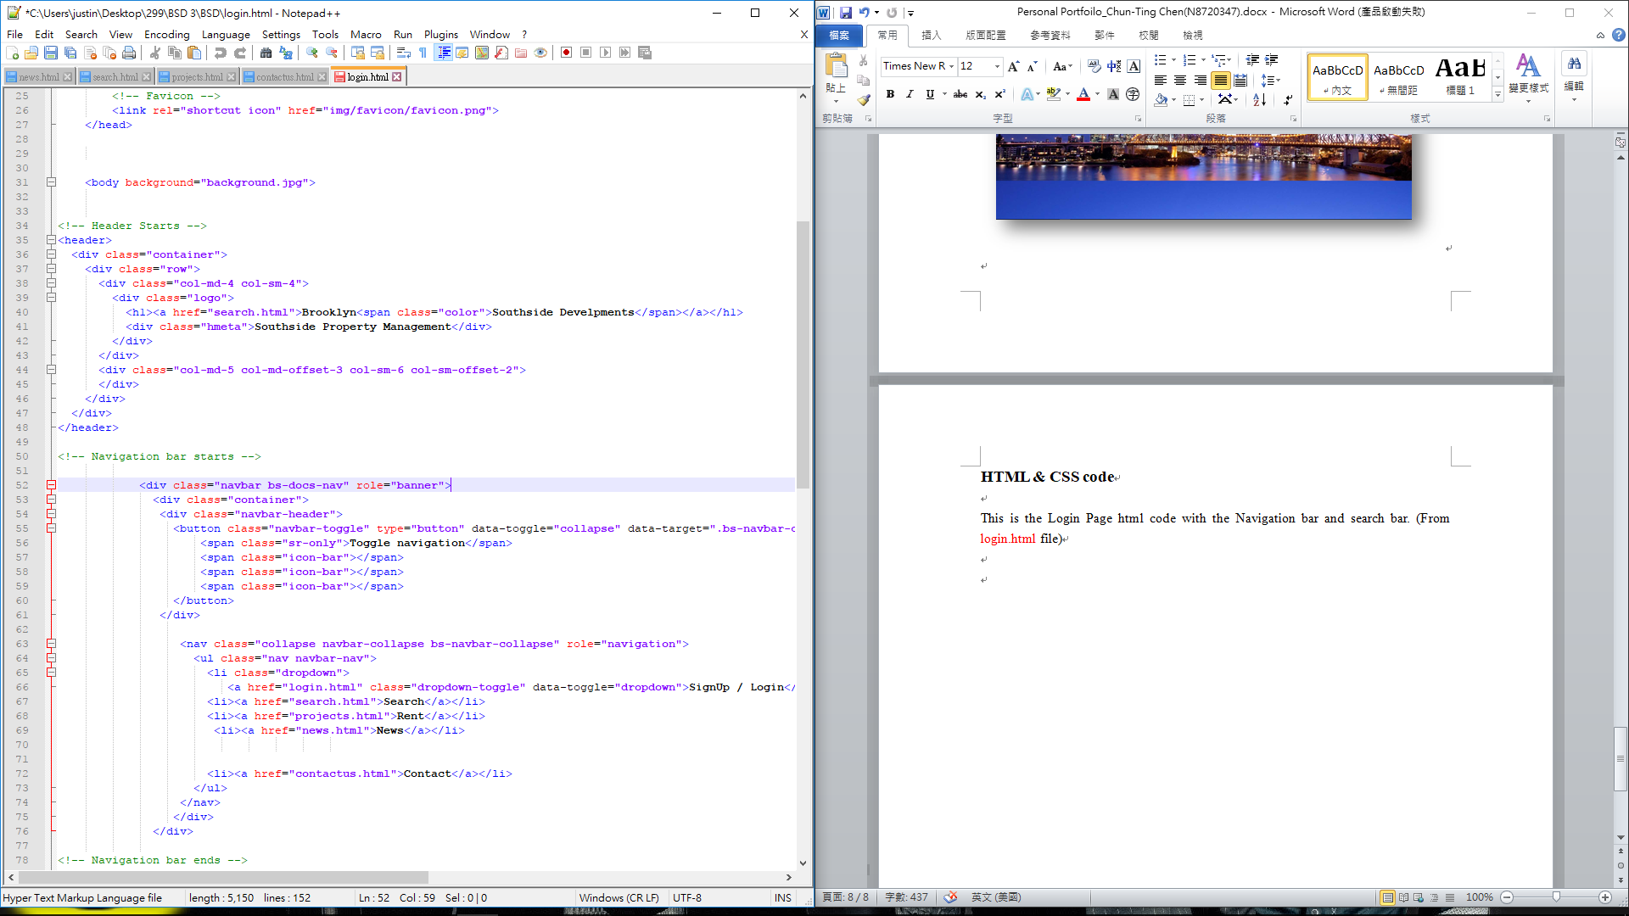

The search Page code was design by me and the page come up with Navigation bar and Search filters. It includes the postcode, location, rating system, viewing time and facilities.(From search.html file)

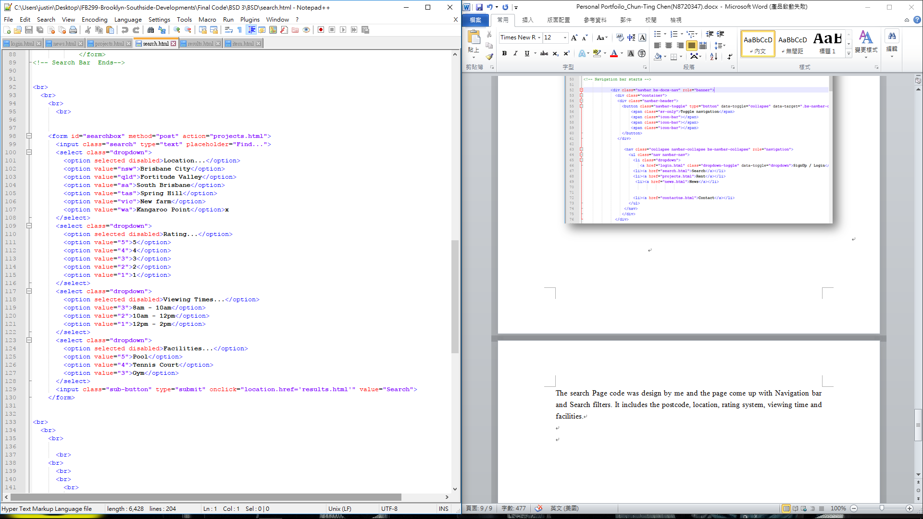

This is the latest news code design by html code. When people try to click on the image, the images will pop-up. Then click on the image or text. It will straight bring you to the property page. (From news.html file)

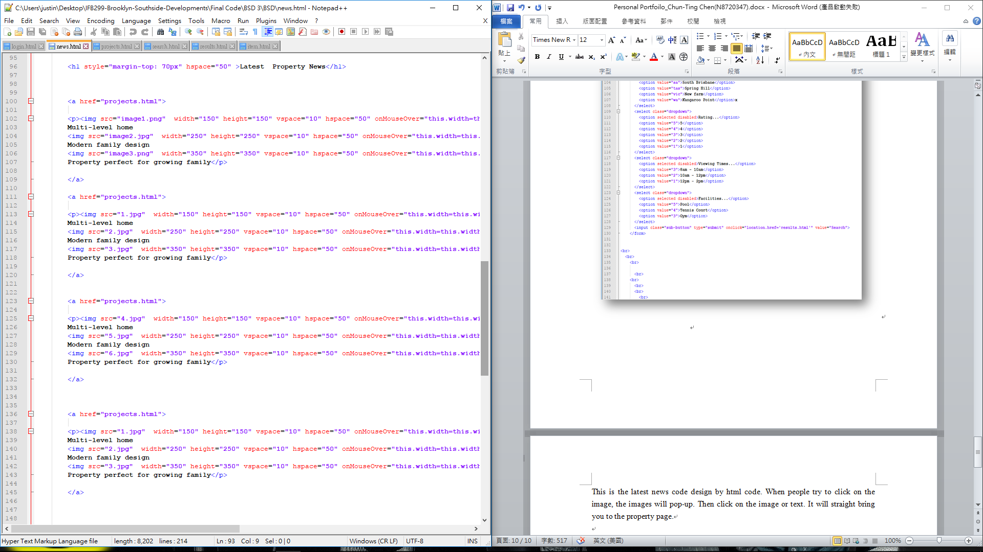

This is the result page it shows the property name, description and rating. And you still can search the location and people who rating for the properties. (From result.html file)

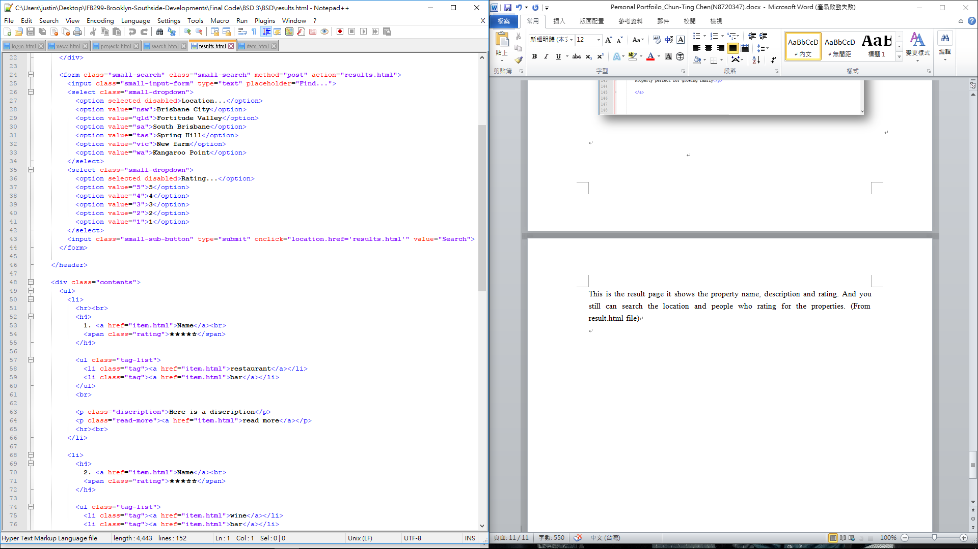

This is the item page html code. It will show the trading time, property image location, rating and email agent form. (From item.html file)

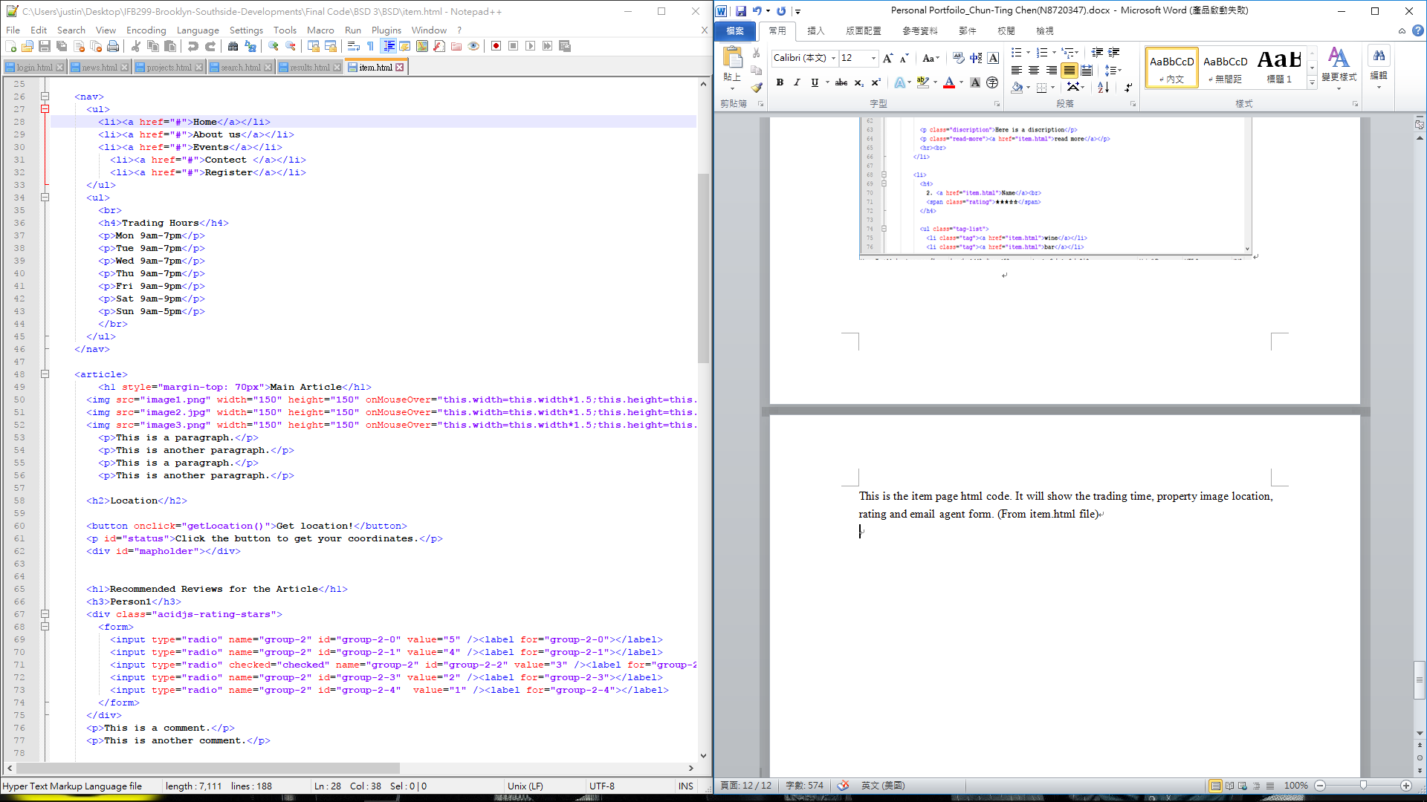

This the CSS code design for the entire web layout, image, bar, header and footer. (From assignment.css file)

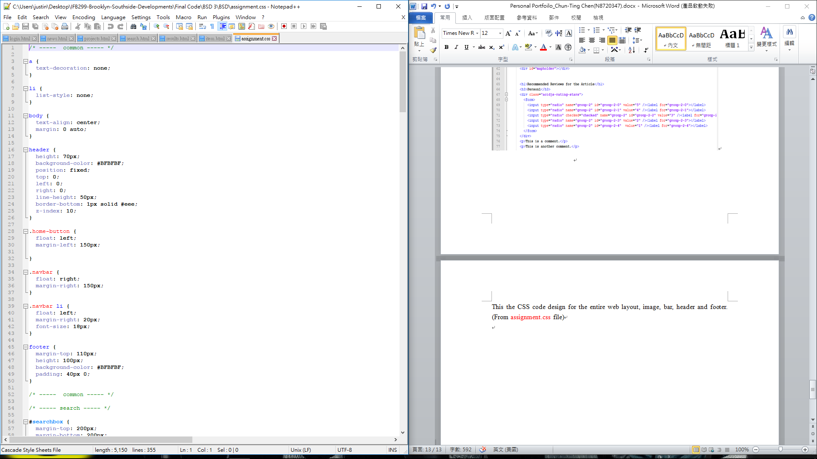

**Test cases**

This is the test case form that I try to test the web page step by step and see the site and the code work or not. (From Test case search & News document)

